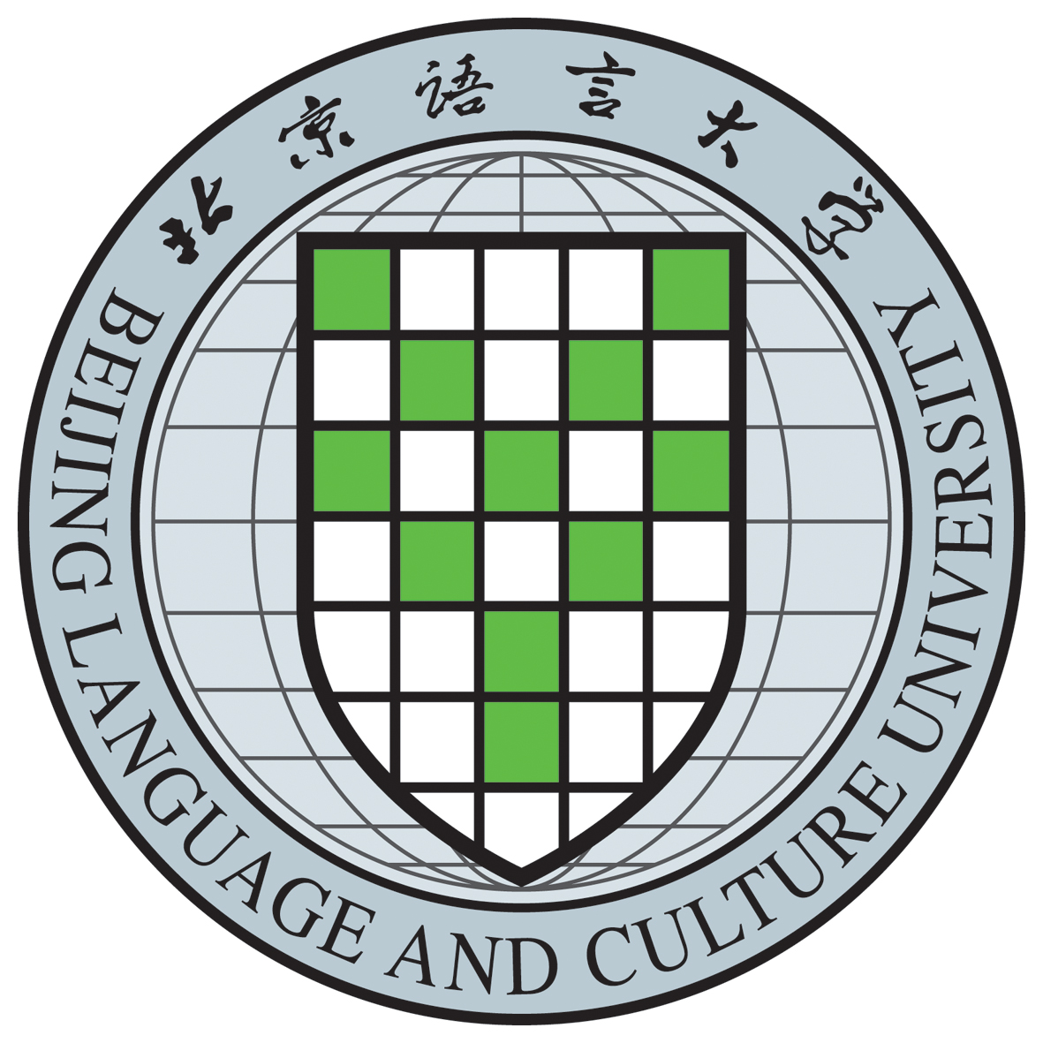

CERTIFICATE OF GRADUATION
(Translation)

This is to certify that Fang Ruoshui, female, born on March 4, 1998, has studied Linguistics and Applied Linguistics from September 2020 to July 2023 at Beijing Language and Culture University and is granted graduation upon completing and passing all the required courses of the three-year graduate program.

Certificate number：100xxxxxxxxxxxxxxx

（注：标黄处需根据自己中文毕业证上的信息填写，需保持完全一致，否则无效。因每届学生情况不同，不可统一规范。请认证时删去此段话，谢谢！）

President：Duan Peng
Beijing Language and Culture University
Issued on July 1，2023

